**Sudjojono, Sindudarsono (1913-1986)**

Sudjojono, more than being a painter, was seminal in developing a discourse of modernity in early 20th century Indonesia. Through his critical writings, the formation of numerous painters’ associations, his political activism and his ties to President Sukarno, Sudjojono married his political aspirations for social equality with his career as a Modernist painter. His commitment to social issues and revealing the “visible soul” in painting instructed what many have described as an honest approach to painting. Sudjojono’s paintings exhibit a modern self-reflexivity and an emotive quality made explicit through a somber palette and expressive brushwork. His paintings that evoke the gritty reality of daily life demonstrate little regard for the illusionistic or academic qualities of earlier Indonesian painters and distinguish him as a pioneer of social realism in Indonesian art. His early life and career tied to Indonesian Independence has been valorized within post-colonial narratives and continues to be a great source of interest for art historians. After his resignation from the Indonesian Communist Party and the *Lembaga Kebudayan Rakyat* (Peoples Cultural League) in 1958, his work largely focused on landscape, still life and family portraits demonstrates a period of introspection and contemplation, whilst interesting, hasn’t attracted the same kind of attention.

Sudjojono was born in Sumatra to Javanese parents who worked as contract labourers on Dutch-owned tobacco plantations. The difficult conditions of his early childhood made acute by the colonial occupation critically informed his commitment to the nationalist movement and to social realism in painting. Due to the family’s difficulties Sudjojono was adopted by the schoolteacher Marsudi Joedkosoemo who taught him the basics of drawing. Whilst still at school he also spent a short time under the tutelage of the illustrator and painter Mas Pirngadie.

In the absence of institutional training centers for artists, painters like Sudjojono honed their skills working informally with senior painters. Whilst Sudjojono exhibited his work at the Congress of Indonesian youth in 1928 it wasn’t until the mid 1930’s that he began to pursue his professional career seriously. In 1934 Sudjojono painted alongside the Japanese painter Chioyi Yazaki at Borobodour and, perhaps as a result of Yasaki’s encouragement, travelled to Singapore in 1935, where he assisted J. Pieres in producing portraits at the Ceylon Art Studio.

On returning to Java, Sudjojono produced illustrations for the Indonesian-language newspapers *Pikiran Rakyat* and contributed theoretical essays on a specifically Indonesian Modernism. His essays were later collated and published in 1946 as *Seniloekis Kesenian dan Seniman* (Painting, Art and Artists). This work still frequently cited as a core text for young artists and art theorists. In 1937 alongside Otto and Agus Djayasuminta he established *Persatuan Ahli Ahli Gambar Indonesia* (Association of Indonesian artists).

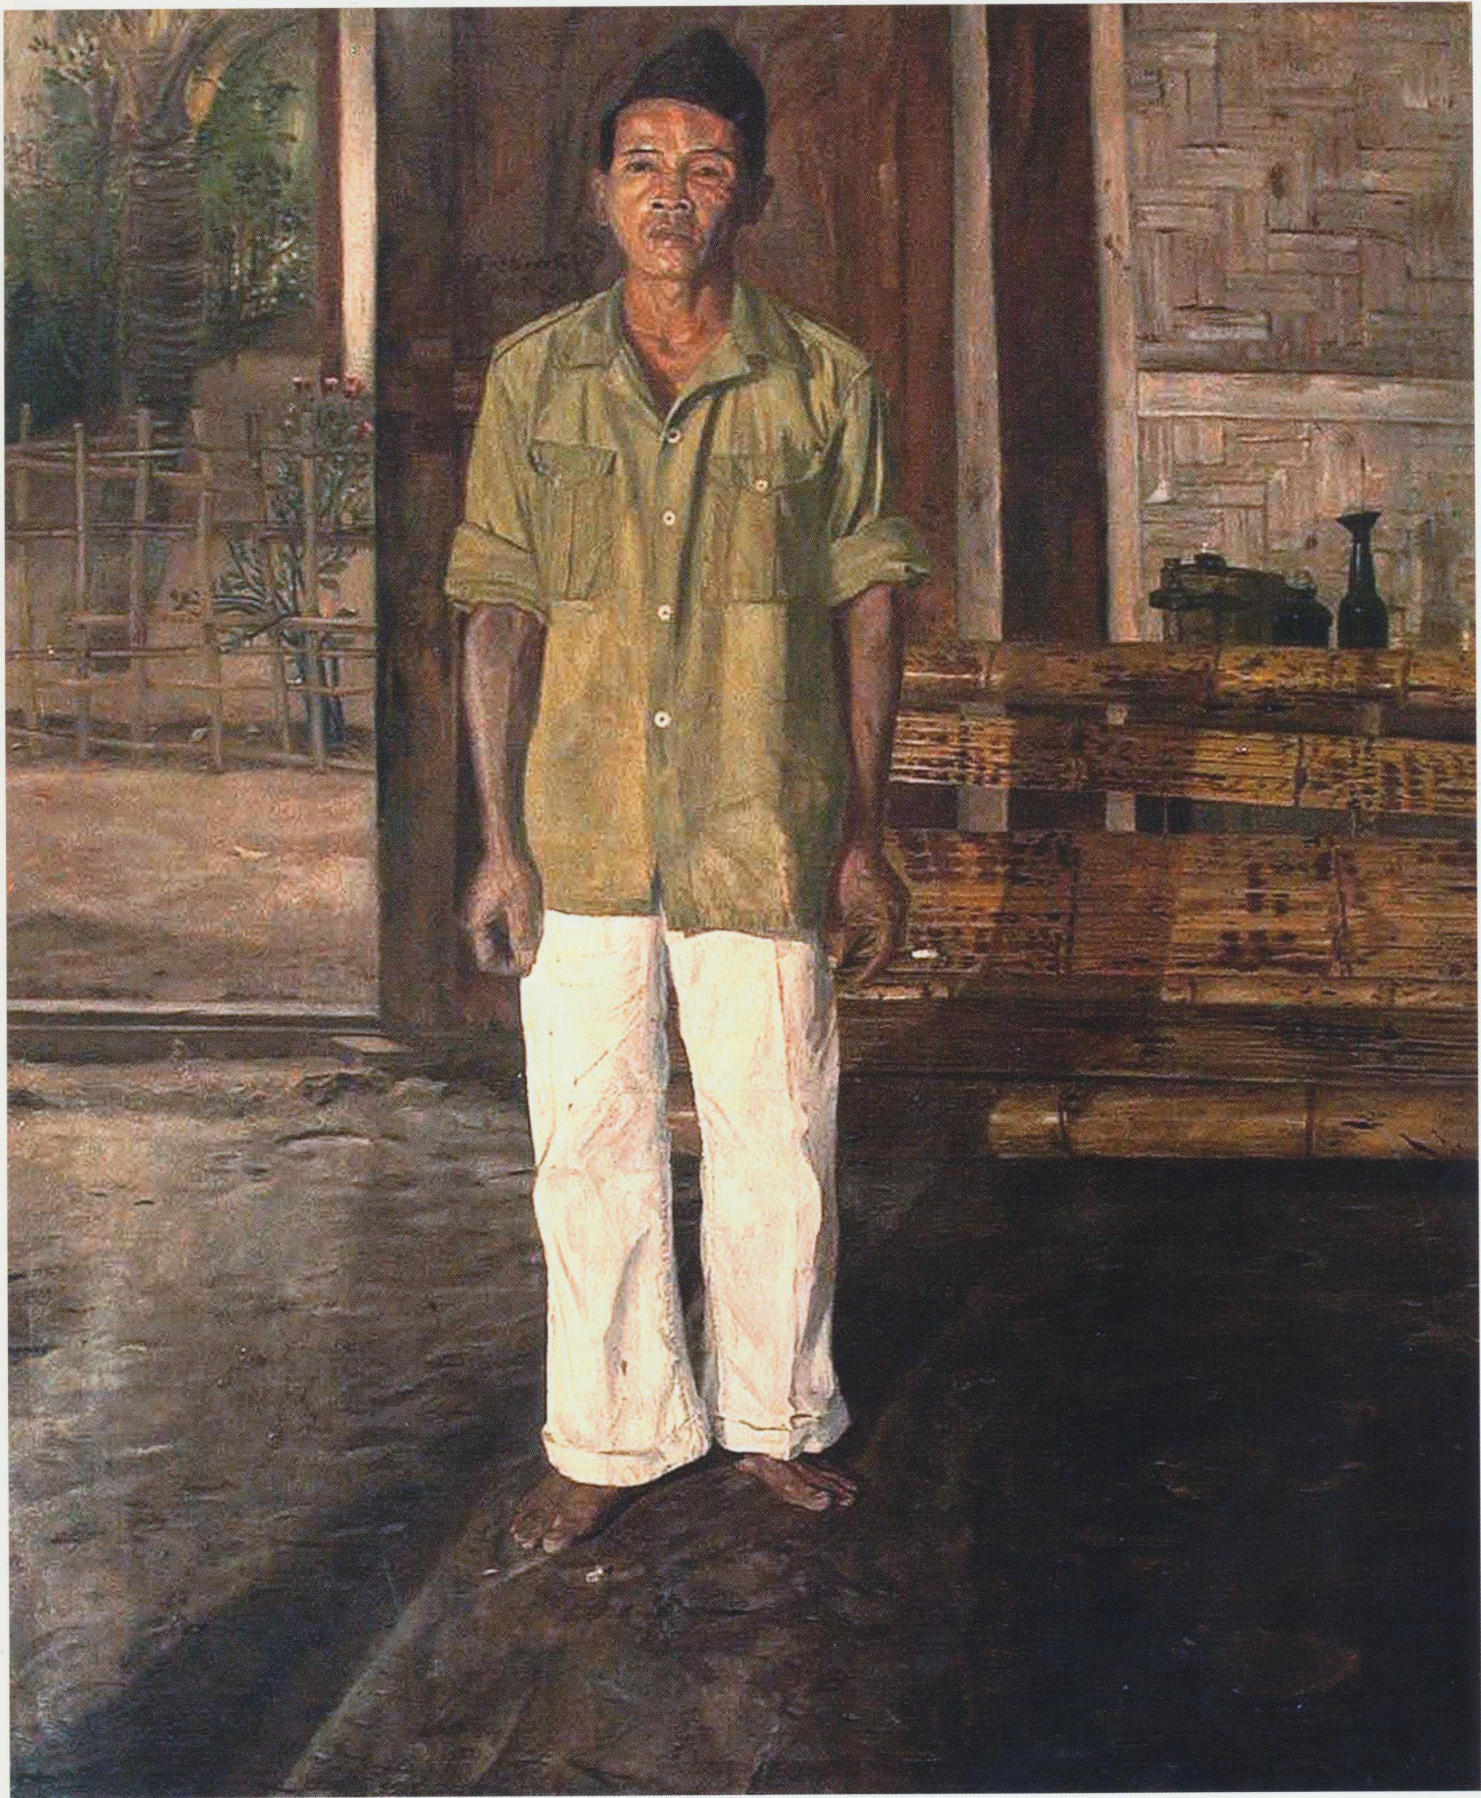

Sudjojono, *Portrait of a Neighbour*, 1950, oil on canvas, 151 x 121 cm

The 1940s was a very turbulent time in Indonesian history and artists like Sudjojono experienced first hand the changing of the guard with the Japanese occupation (March 1942- August 1945), the declaration of Independence on 17 August 1945, and the ensuing four-year bloody conflict to have their independence recognised. Whilst traumatic, the Japanese occupation presented new opportunities for Indonesian politicians and artists. Sudjojono became deputy of the Cultural Divisionof the newly established *Poesat Tenaga Rakyat* (Center for Peoples Resources) and later joined *Kemin Bunka Shidosho* (Instructional Institution for Cultural Enlightenment of the People) the Japanese equivalent managed by his long-term ally Agus Djayasuminta. Skills developed at these centers were later used to produce propaganda posters in support of the Independence struggle. Whilst Sudjojono led smaller painting associations during the struggle many of his own paintings were destroyed. However, with the Republic established, his friendship with President Sukarno gave rise to new commissions which in celebrating the heroism of the revolution cemented his place in Indonesian art history.

**References and further reading**

Sudjojono, S. (1946). *Seni Loekis di Indonesia sekerang dan jang akan datang,. Seni Loekis, Kesenian dan Seniman,* JogjakartaL Indonesia Sekerang.

Sidharta, A. (2006). *S.Sudjojono Visible Soul*, Jakarta: Museum S. Sudjojono.

Bustam, M. (2006). *Sudjojono dan Aku*, Jakarta: Pustaka utan Kayu.

Spanjaard, D. H. (2003). *Modern Indonesian Painting*, Singapore: Sotheby's up productions.